Contents

**Task1** 3

**Task2** 24

**Task3** 44

**Task4** 46

**Task5** 49

References 50

# **Task1**

**Home Page (fig1)**

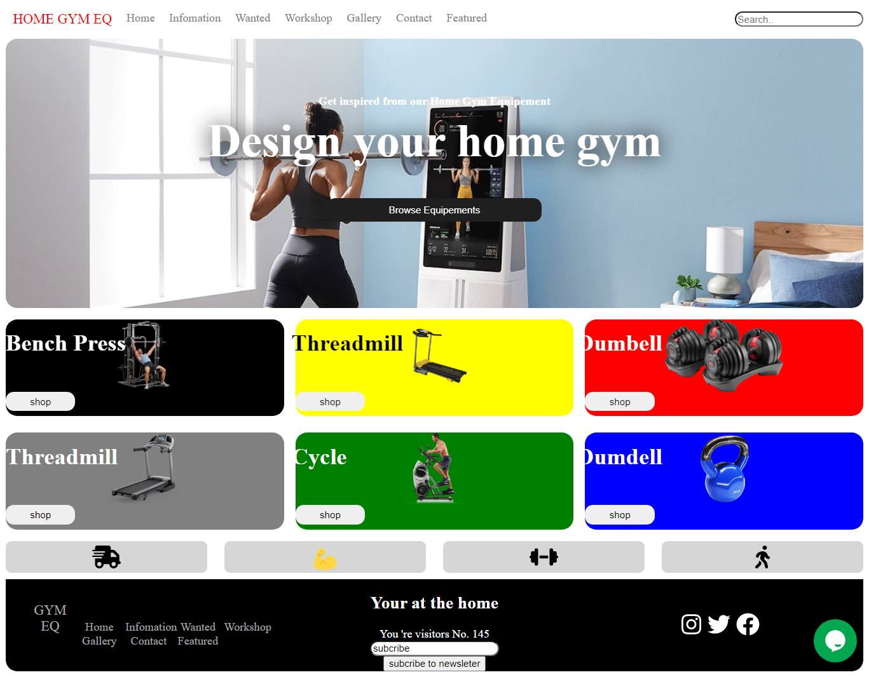

**(fig1.5)**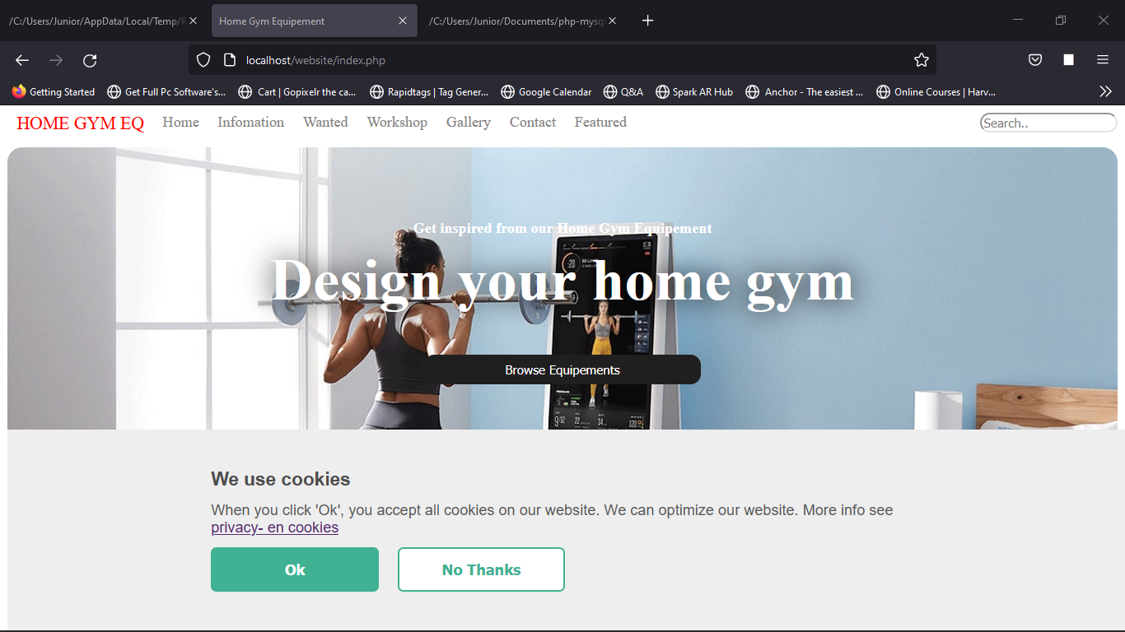

The Responsive Home page of the Home GYM Equipment contains **; relevant images, and two videos, a search bar, slide show, visitor counter, cookies and interactive navigation**

**Information Page (fig2)**

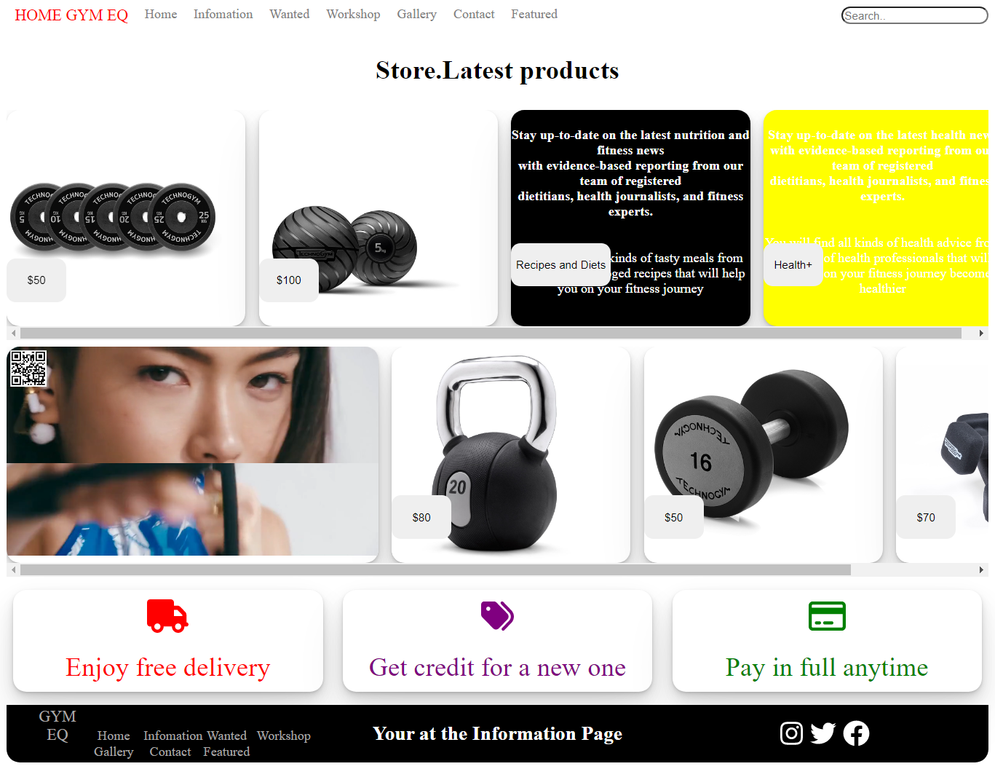

This page contains relevant images and sections for ‘**Latest products** ’ with **fitness information**

**Wanted Page (fig3)**

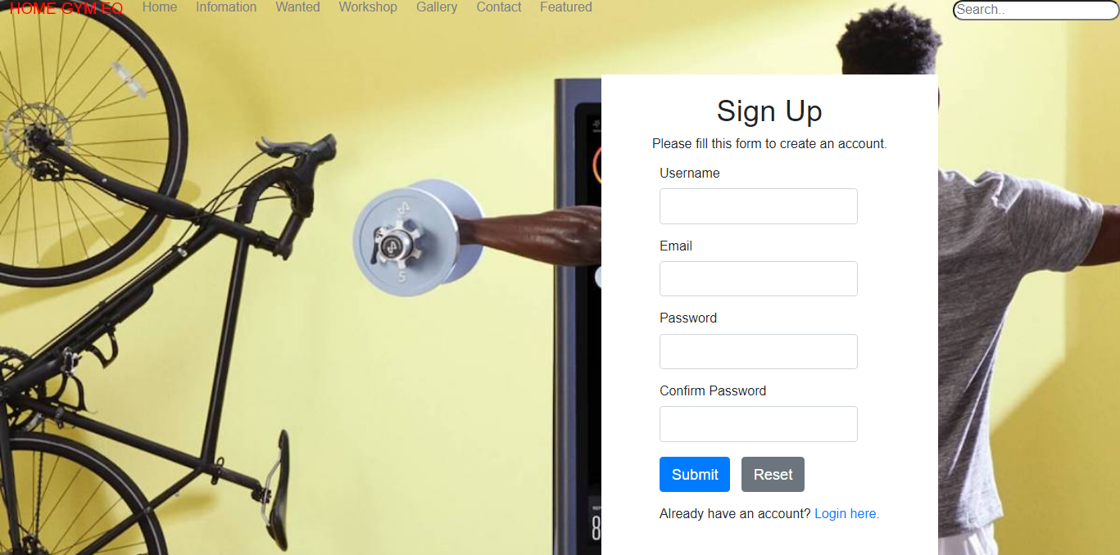

**(fig3.5)**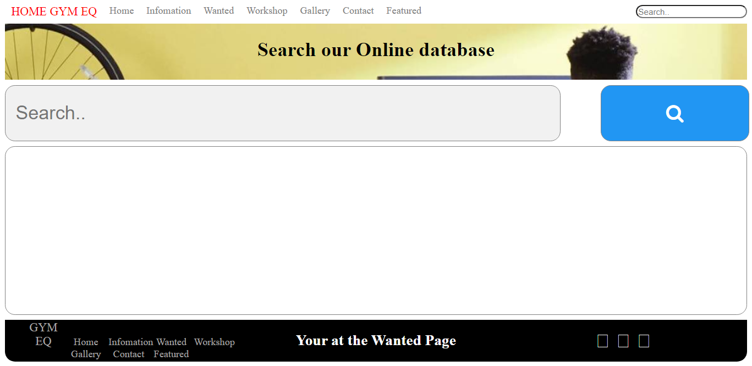

Customers can **create an account** which is stored in the database, then, login to **search the database** for relevant home equipment’s.

**(fig3.6)**

Searching the database

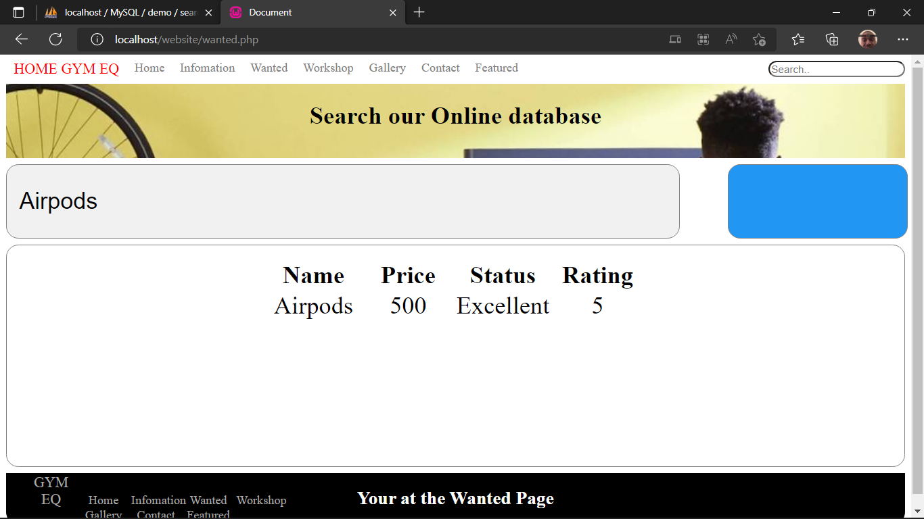

**Workshop Page (fig4)**

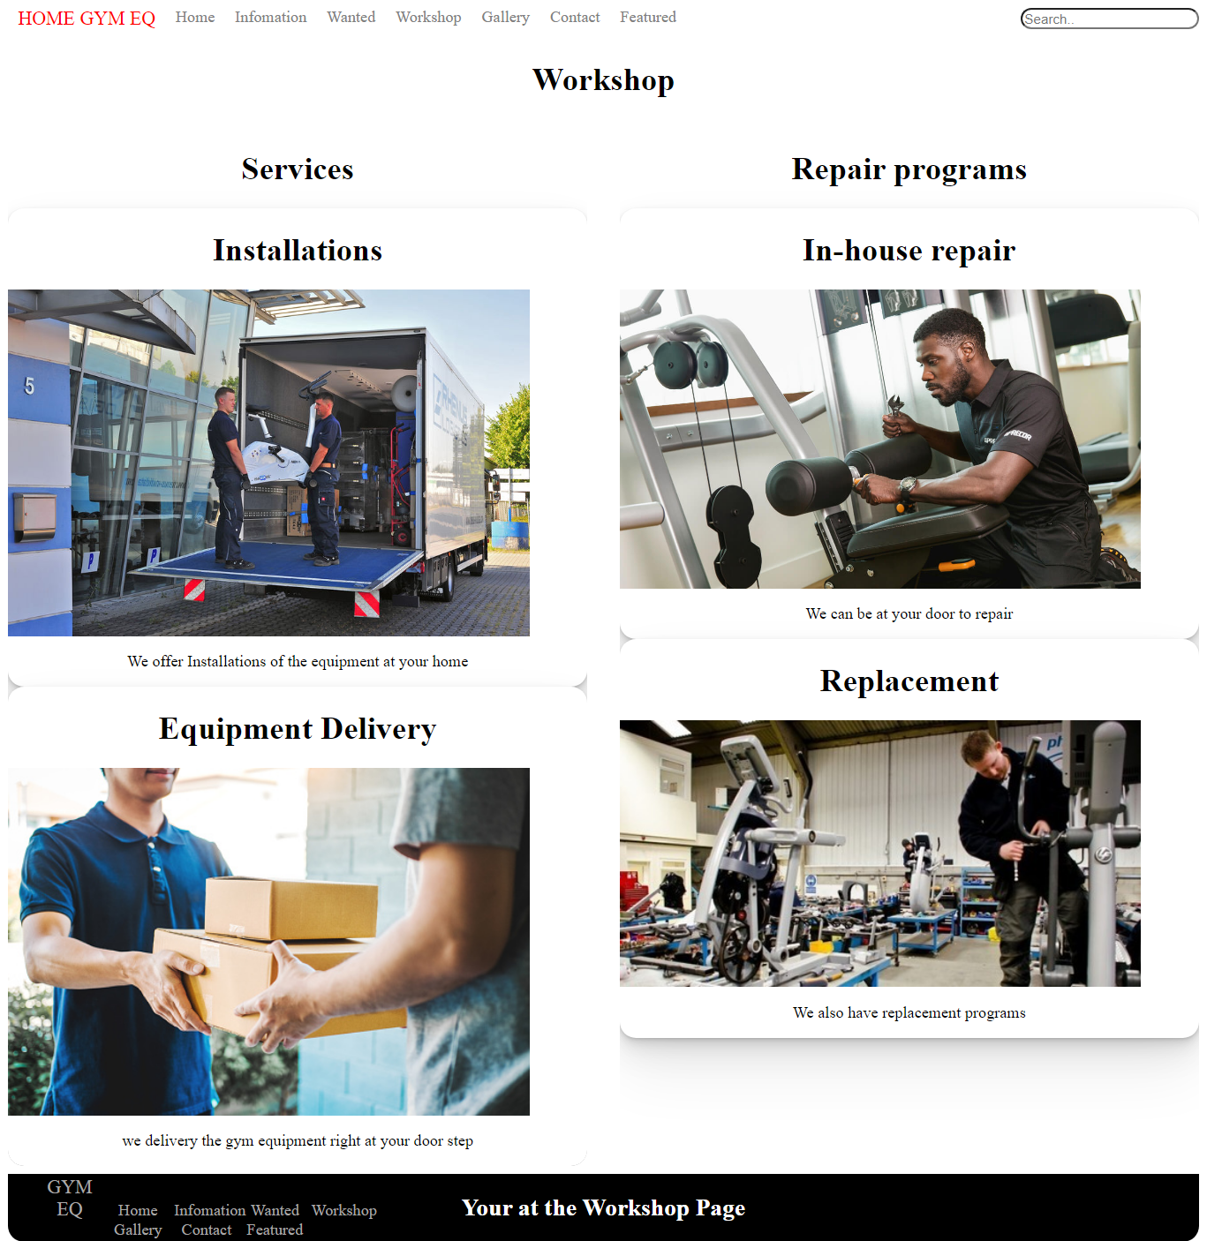

This page shows the **services** and **repairs** provides by Home Gym Equipment

**Gallery Page (fig5)**

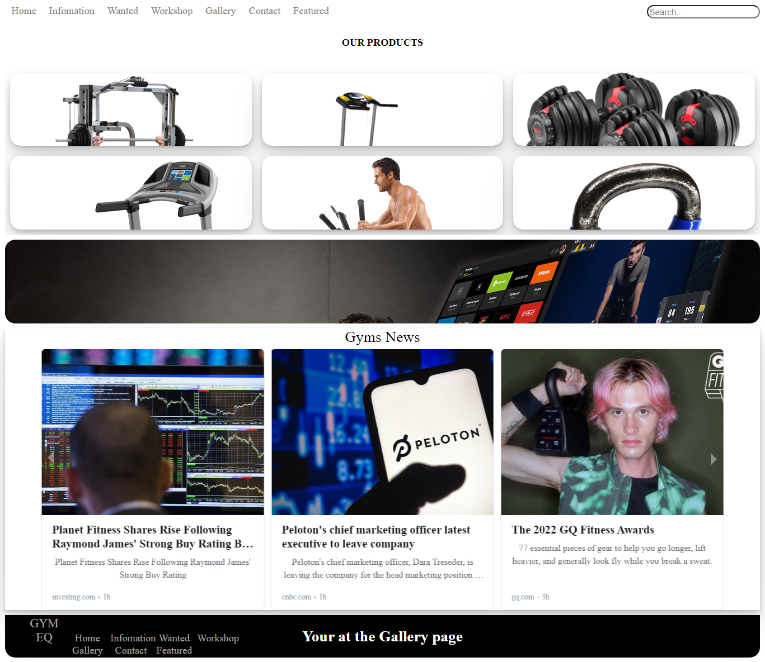

This page contains the ‘**RSS Feed**’ and sections for ‘**Our products** ’

**Contact Page (fig6)**

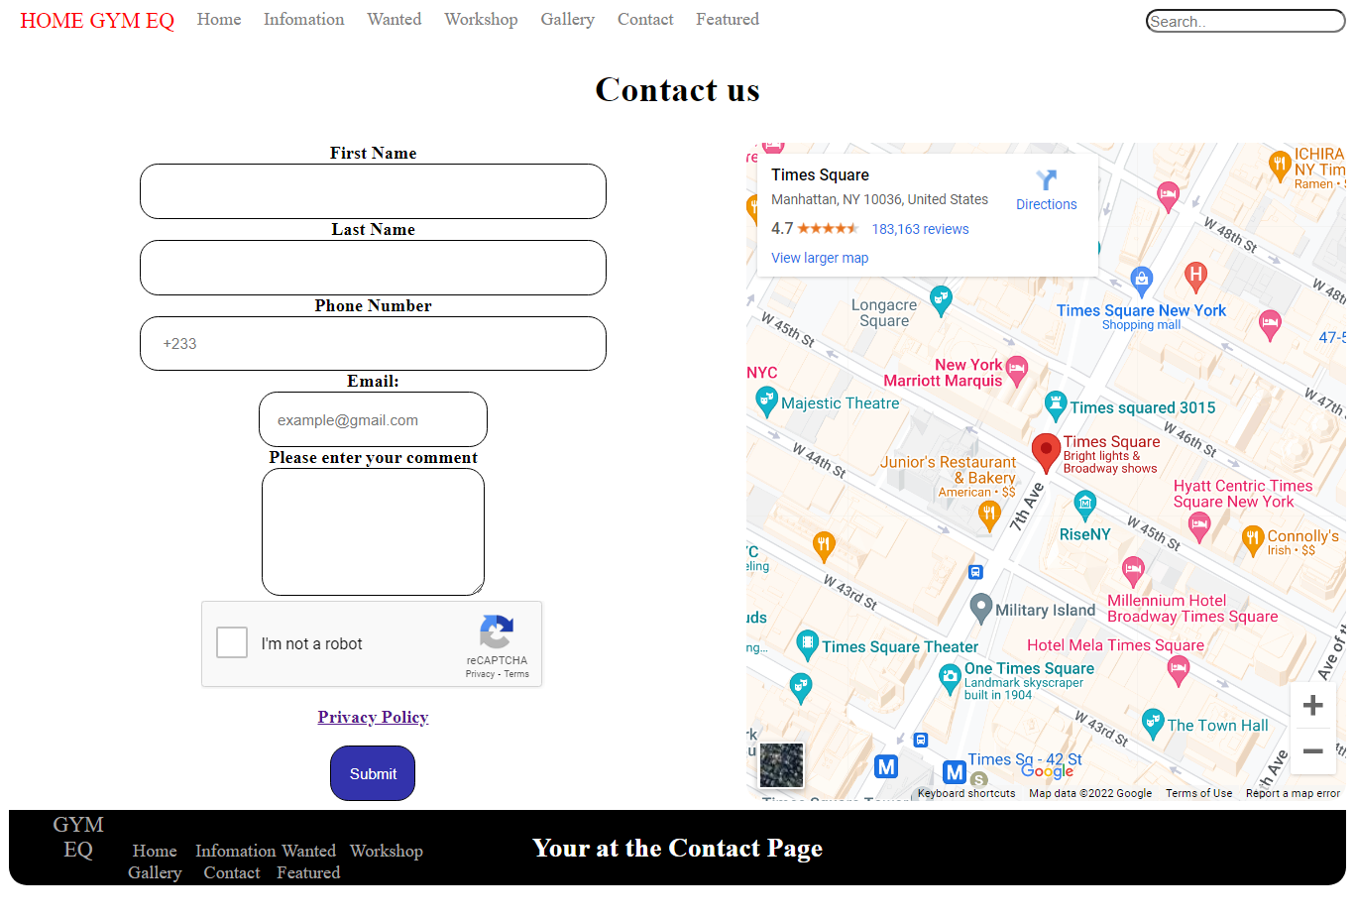

**(fig6.5)**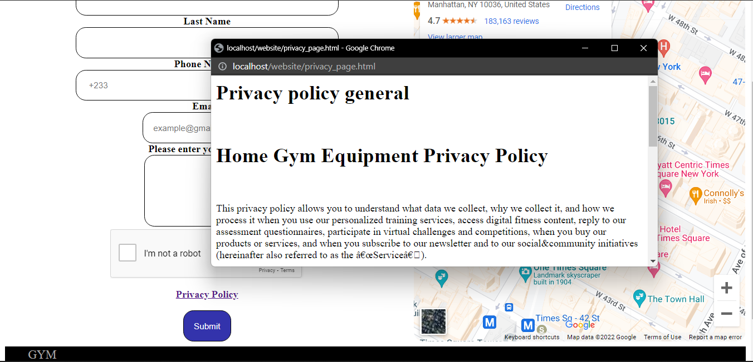

This page contains a contact **form** with a ‘**Recaptcha**’ and link to ‘**Privacy Policy** ’

**Featured Page (fig7)**

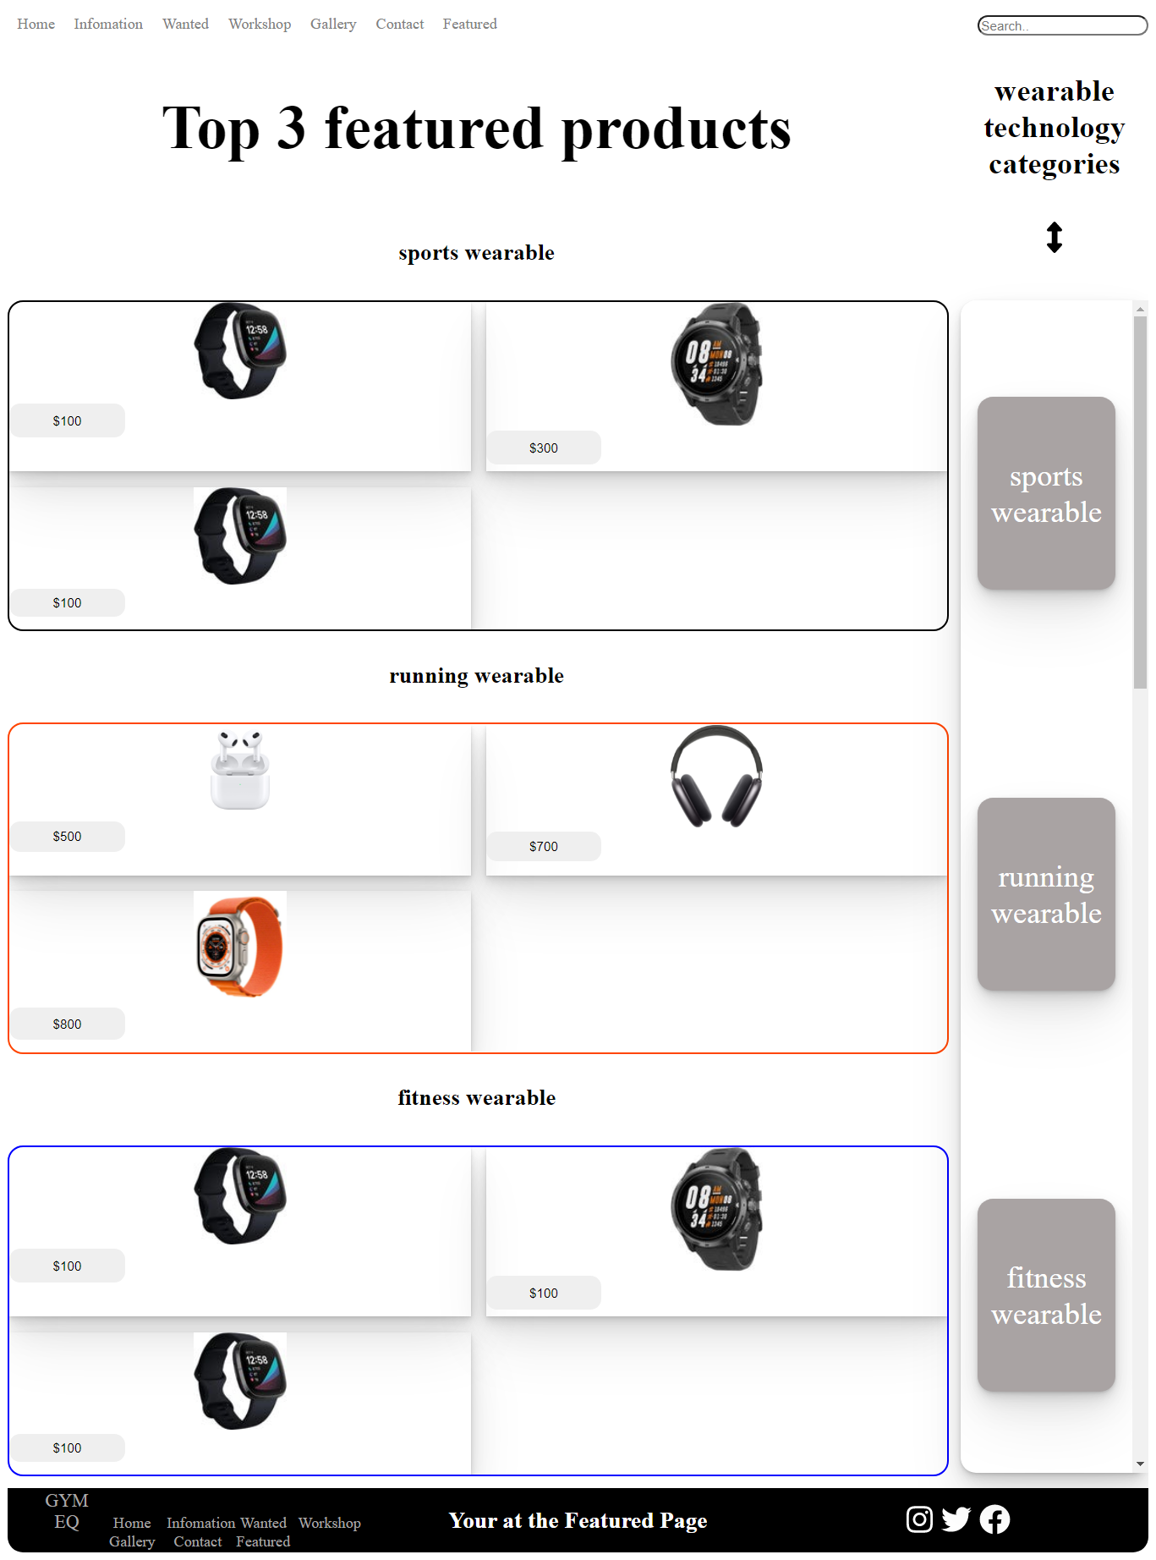

This page contains a review of ‘**Wearable technology** ’ and a ‘**wearable technology category’** on the right side

**(fig7.5)**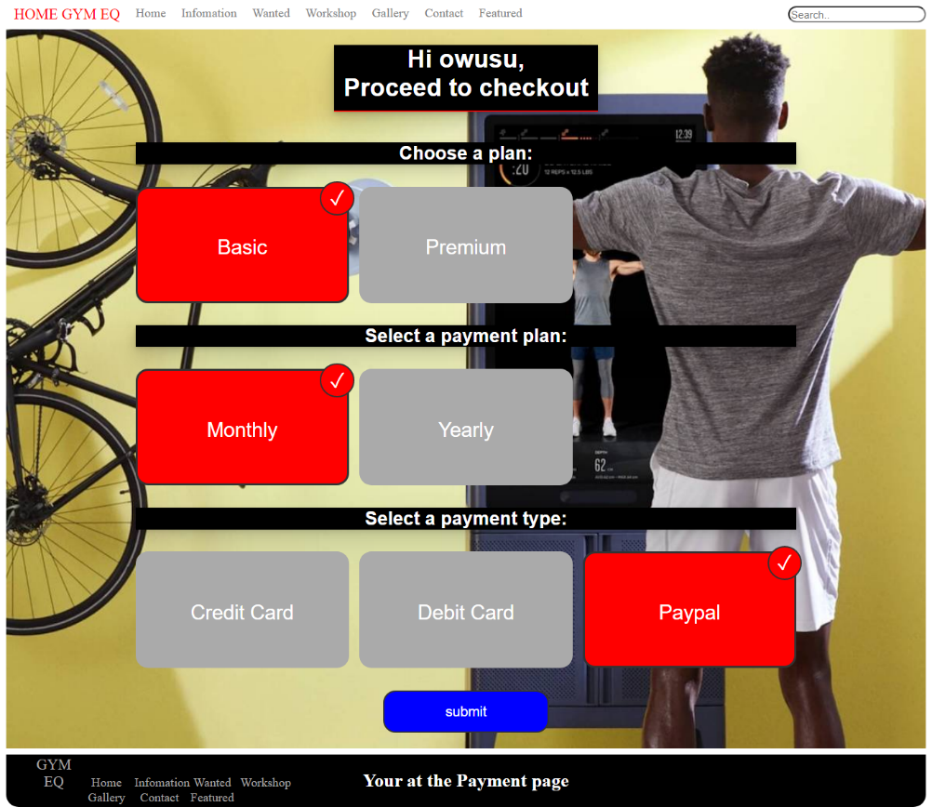

The feature page also links to a ‘**payment plan’** when a product is selected

1. **Usability across Browser**

**Usability on Chrome Browser (fig8)**

The website in the chrome browser

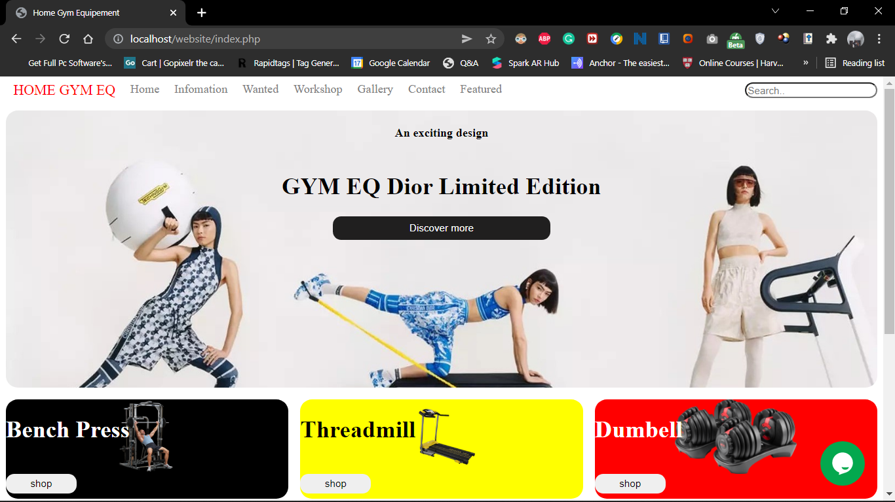

**Usability on Firefox Browser (fig9)**

The website in the firefox browser

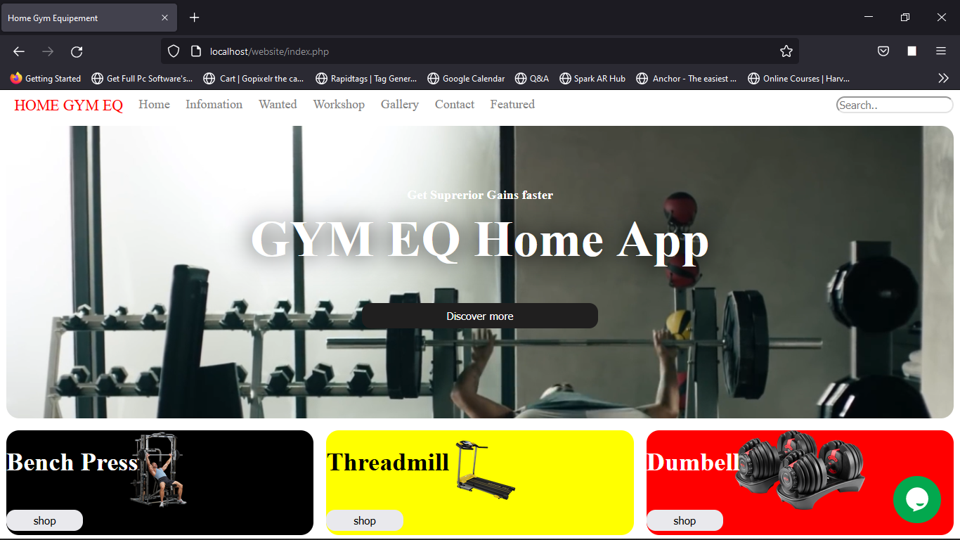

**Usability on Mobile Browser (fig10)**

The website in a mobile browser

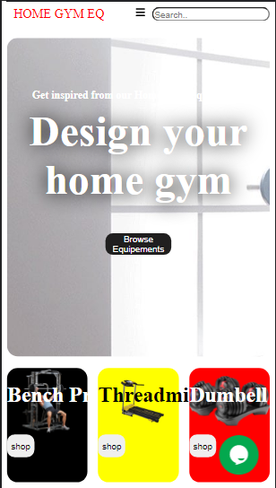

1. **Responsive image (fig11)**

Images used in the website

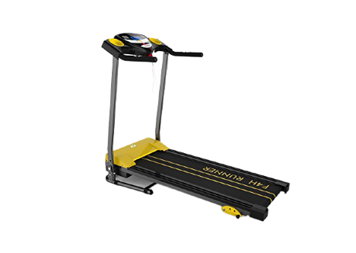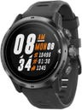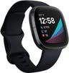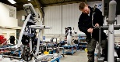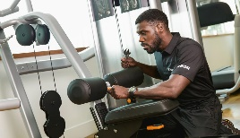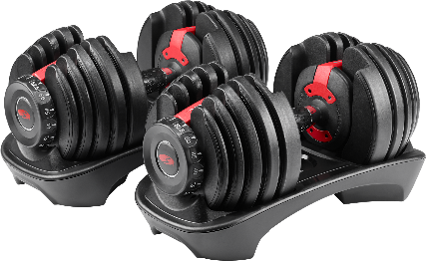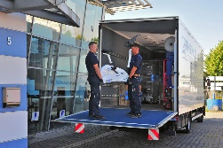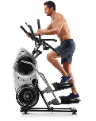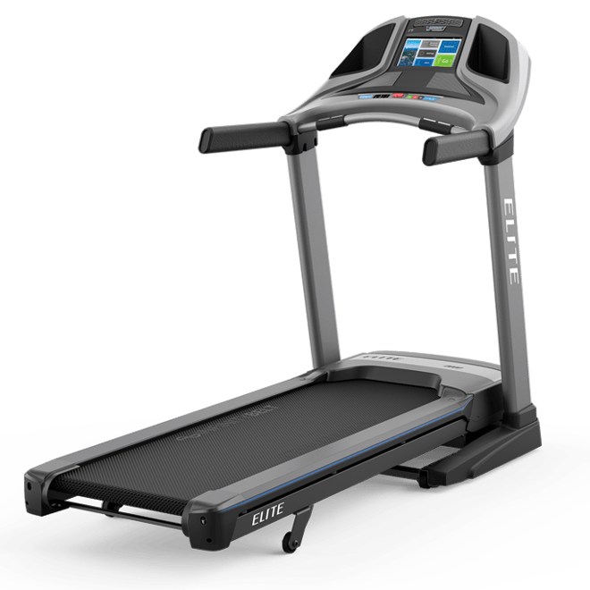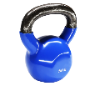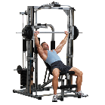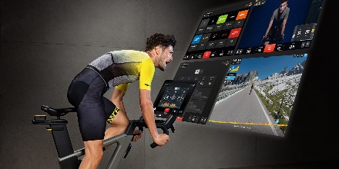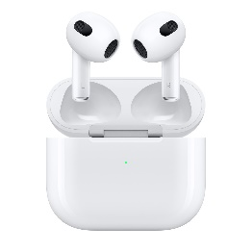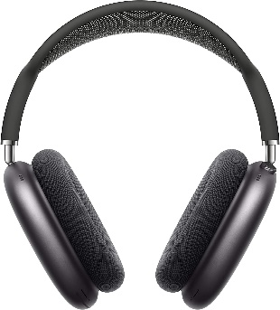

1. **A search bar (fig12)**

It is located on **the top right corner** of the navigation bar

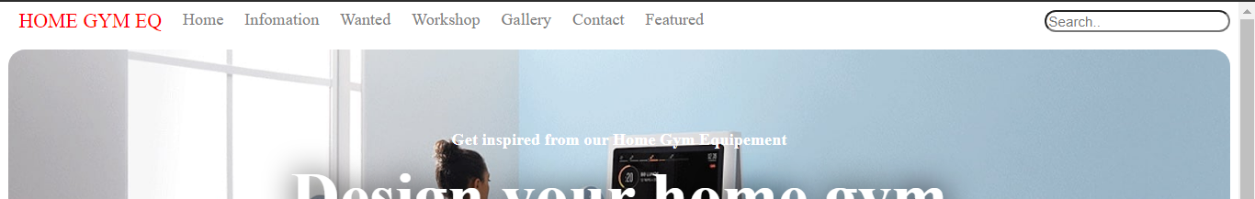

1. **Cookie information (fig13)**

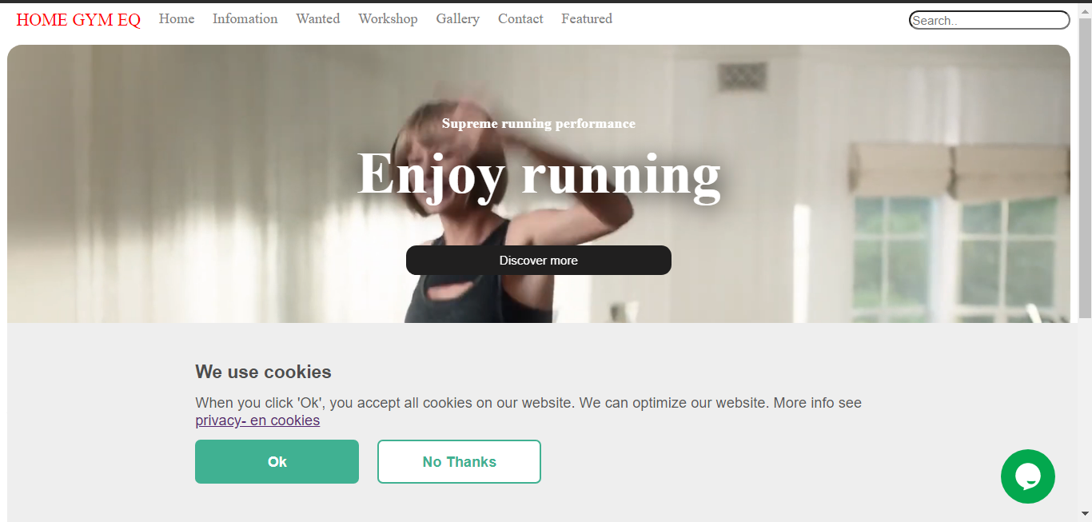

1. **Slide show (fig14)**

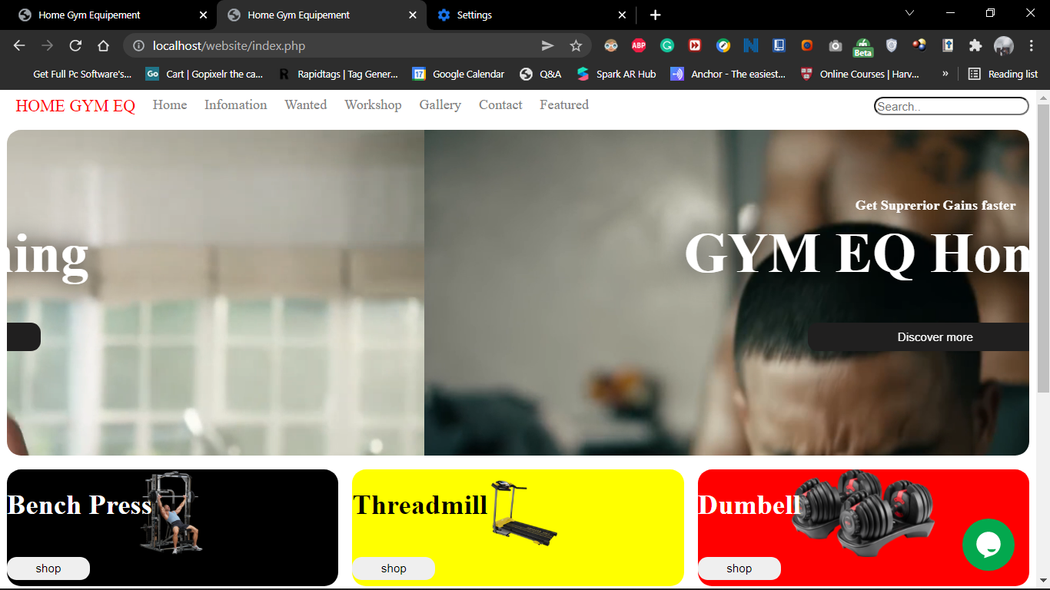 **(fig14.5)**

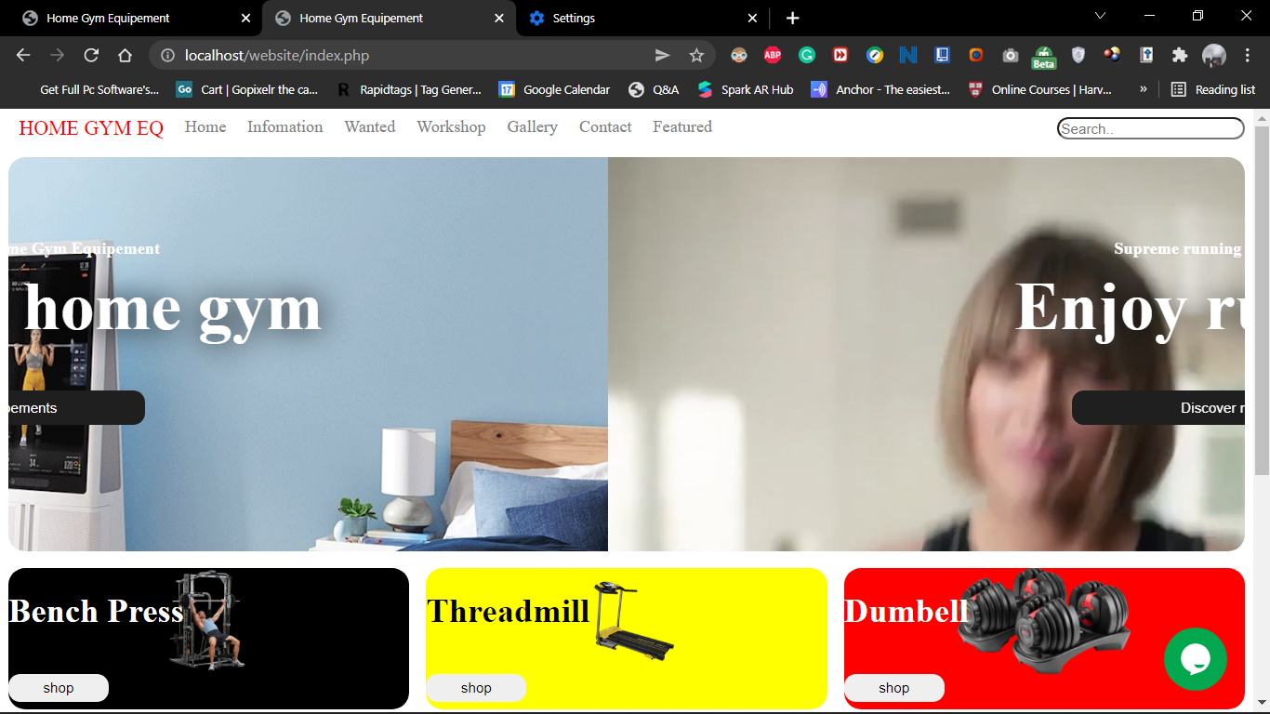 The slideshow which **contains 2 videos** and relevant information

1. **Interactive Navigation bar (fig15)**

The navigation bar changes into a **hamburger menu**

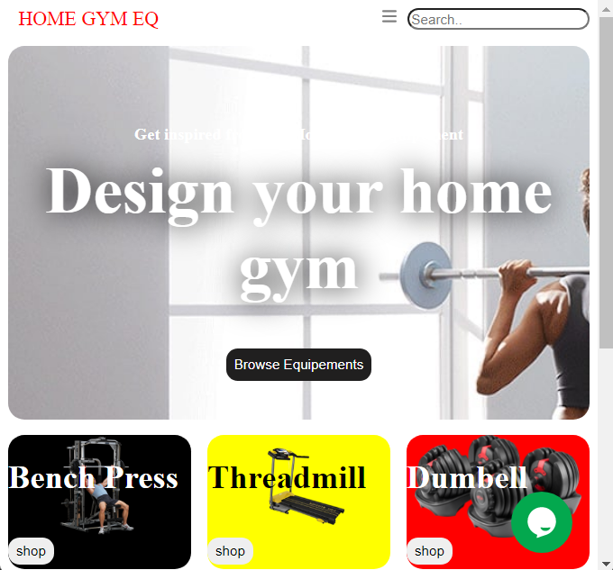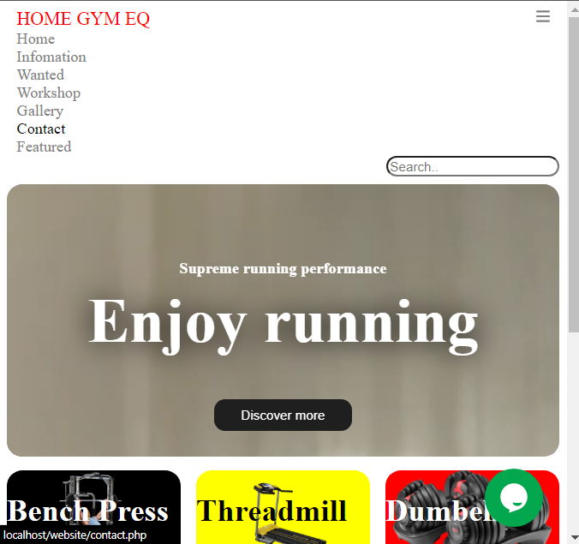

1. **Header {logo, call to action, text or navigational elements} (Fig16).**



1. **Number of views counter (fig17)**

It is located at the **footer** at the ‘**You’re visitor No**.’

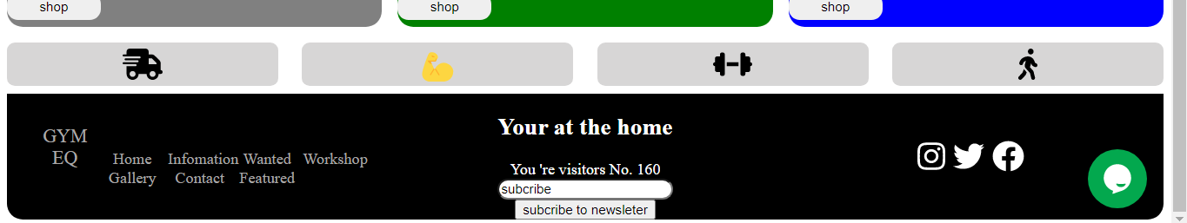

1. **Footer with;** "you are here," "copyright information," and social media links (fig. 18).



1. **Online responsive contact form and login page (fig20)**

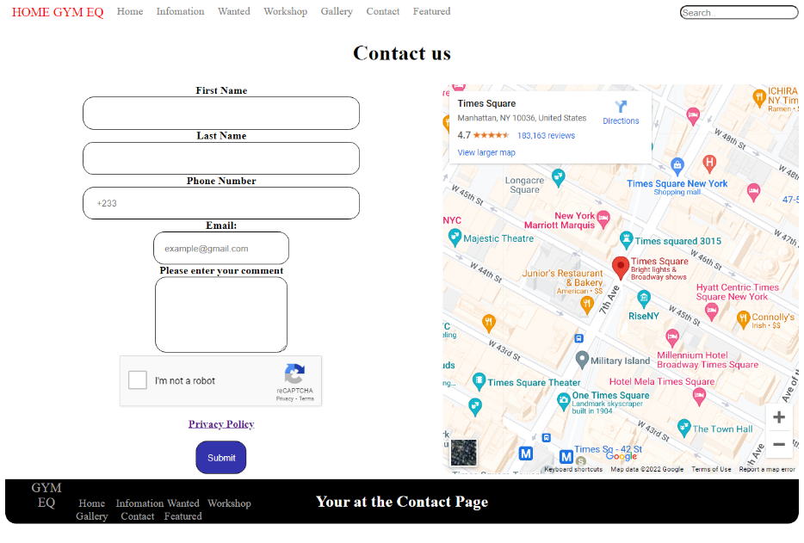

**(fig20.5)**

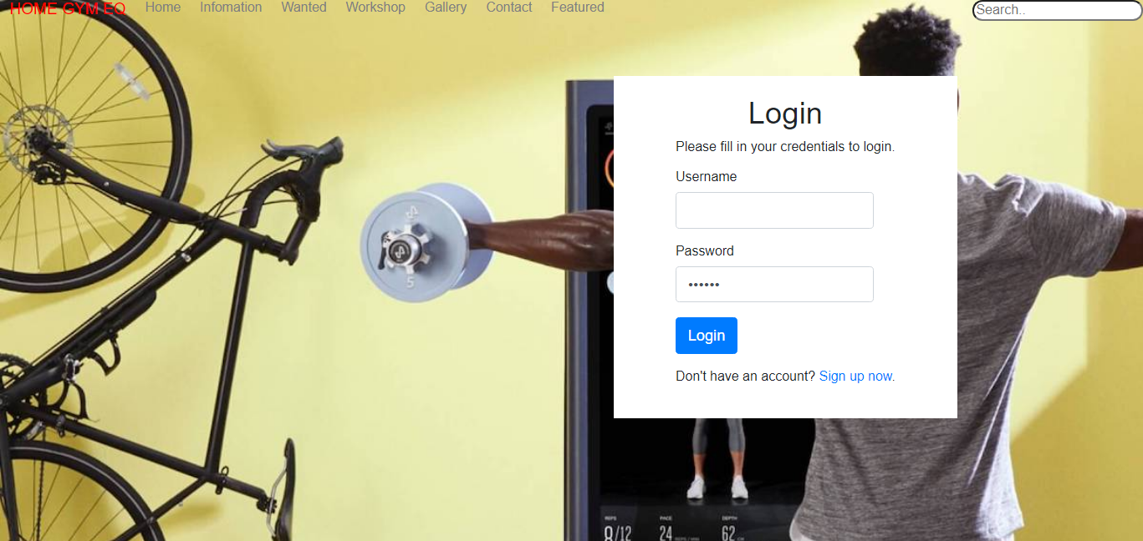

1. **RSS feed. (fig21)**

It is located on the **featured page**

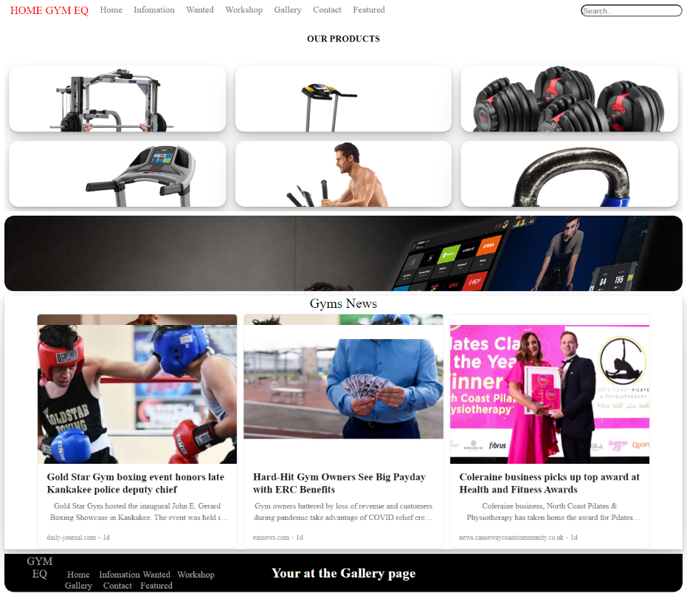

1. **Contact us form including privacy policy (fig22)**



1. **The "wearable technology categories" sidebar on the featured page (fig23)**

It is located on the **right side** of the featured page

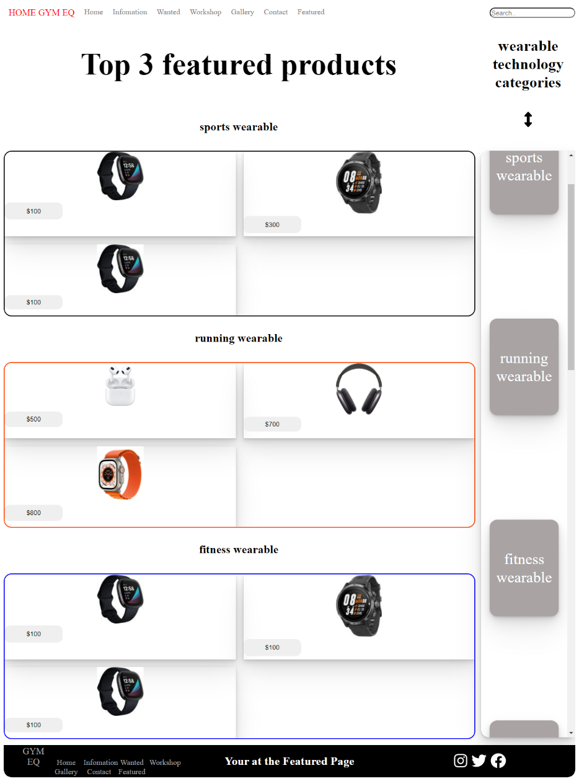

1. **Two different web services (fig24)**

* **Tawk.to (chatbot web service)**

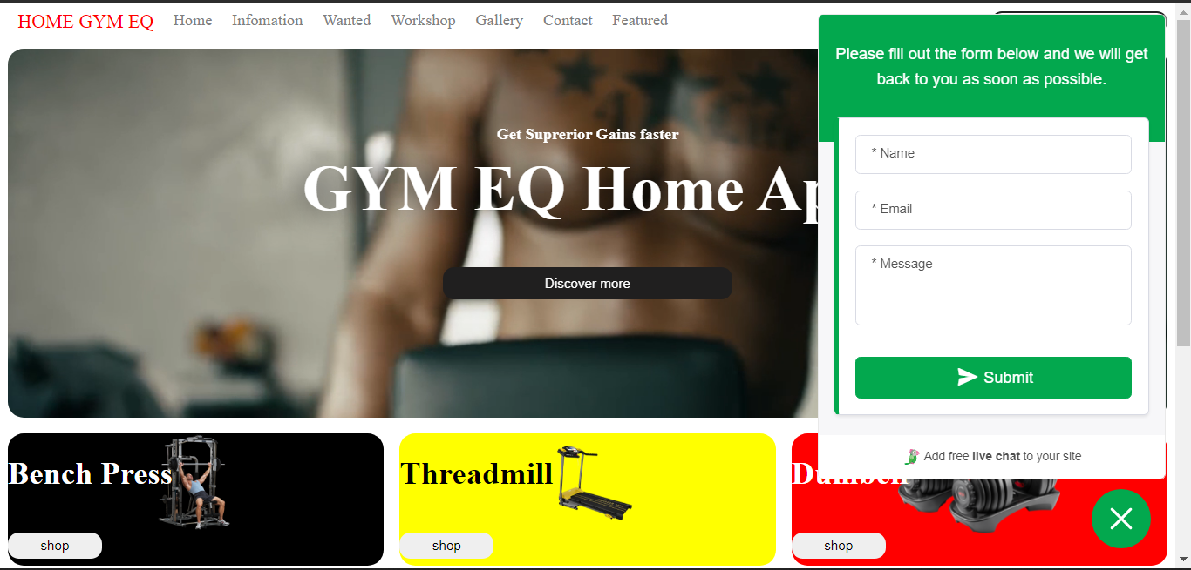

* **Recaptcha**



# **Task2**

**External CSS**

body {

    scroll-behavior: smooth;

    font: sans-serif;

}

.container {

    display: grid;

    height: 160vh;

    grid-template-rows: .2fr 2.5fr 1fr 1fr .3fr .5fr;

    text-align: center;

    margin-top: .5rem;

    gap: .5rem;

}

nav a {

    text-decoration: none;

    float: left;

    margin: 0 10px;

    color: gray;

}

nav a:hover {

    color: black;

}

.search {

    float: right;

    border-radius: 1rem;

    max-width: auto;

}

.logo {

    font-size: larger;

    color: red;

}

.rnav .icon {

    display: none;

}

@media screen and (max-width: 900px) {

    .rnav a:not(:first-child) {

        display: none;

    }

    .rnav a.icon {

        float: right;

        display: block;

    }

}

@media screen and (max-width: 600px) {

    .rnav.responsive {

        position: relative;

    }

    .rnav.responsive .icon {

        position: absolute;

        right: 0;

        top: 0;

    }

    .rnav.responsive a {

        float: none;

        display: block;

        text-align: left;

    }

}

.reg {

    display: grid;

    place-items: center;

    background-color: rgb(225, 224, 224);

    color: white;

}

.reg1 {

    display: grid;

    place-items: center;

    background-color: rgb(70, 69, 69);

    color: white;

}

.slider {

    max-width: 100%;

    border-radius: 1rem;

    overflow: hidden;

}

#slider figure {

    position: relative;

    width: 500%;

    margin: 0;

    left: 0;

    animation: 25s slider infinite;

}

#slider figure div {

    width: 20%;

    float: left;

}

@keyframes slider {

    0% {

        left: 0;

    }

    20% {

        left: 0;

    }

    25% {

        left: -100%;

    }

    45% {

        left: -100%;

    }

    50% {

        left: -200%;

    }

    70% {

        left: -200%;

    }

    75% {

        left: -300%;

    }

    95% {

        left: -300%;

    }

    100% {

        left: -400%;

    }

}

.txt {

    position: absolute;

    z-index: 2;

    top: 10%;

    color: white;

    display: grid;

    place-items: center;

}

.vid {

    z-index: 1;

    display: grid;

    place-items: center;

    width: 100%;

}

@media only screen and (max-width:934px) {

    .vid {

        width: auto;

        object-fit: fill;

    }

    img {

        width: auto;

        object-fit: fill;

    }

}

@media only screen and (max-width:600px) {}

.txt button {

    height: 2rem;

    width: 10%;

    background-color: rgb(32, 31, 31);

    color: white;

    text-align: center;

}

.dior {

    color: black;

}

.font1 {

    position: relative;

    top: 3.5rem;

}

.font2 {

    font-size: 4rem;

    text-shadow: .5px .5px 30px black;

}

.EQ {

    width: 100%;

    float: right;

    z-index: 1;

    object-fit: contain;

}

.Row {

    display: flex;

    gap: 1rem;

    align-items: center;

    width: 100%;

}

.Row h1 {

    color: white;

    position: absolute;

    z-index: 3;

    float: right;

}

.c1 .blk {

    color: black;

}

.flex {

    height: 90%;

    border-radius: 1rem;

}

.Prp1 {

    background-color: black;

}

.Prp2 {

    background-color: yellow;

}

.Prp3 {

    background-color: red;

}

.Pro1 {

    background-color: gray;

}

.Pro2 {

    background-color: green;

}

.Pro3 {

    background-color: blue;

}

.c1 {

    width: 100%;

    flex: 1;

    object-fit: cover;

    object-position: center;

    overflow: hidden;

    transition: 0.2s all cubic-bezier(0.175, 0.885, 0.32, 1.275);

    cursor: pointer;

    overflow: hidden;

    z-index: 3;

}

.Row :hover {

    flex: 3;

}

.Row1 {

    display: grid;

    gap: 1.5rem;

    grid-template-columns: repeat(4, 1fr);

}

.dsc {

    background-color: rgb(215, 214, 214);

    border-radius: .5rem;

    display: grid;

    place-items: center;

    font-size: 2rem;

}

button {

    min-width: 25%;

    height: 20%;

    border-radius: .7rem;

    display: grid;

    place-items: center;

    border: none;

}

.shop {

    float: left;

    z-index: -1;

}

.Row button:hover {

    transform: scale(1.1);

    margin-left: 1rem;

}

footer {

    background-color: black;

    color: white;

    display: grid;

    place-items: center;

    border-bottom-left-radius: 1rem;

    border-bottom-right-radius: 1rem;

    display: grid;

    grid-template-columns: 1fr 1fr 1fr;

}

.fnav a {

    text-decoration: none;

    color: rgb(169, 167, 167);

    display: inline-block;

    width: 4rem;

}

.social {

    font-size: 2rem;

    margin: 0 10px;

}

.container1 {

    display: grid;

    height: 160vh;

    grid-template-rows: .2fr .2fr 2fr 2fr 1fr .5fr;

    text-align: center;

    gap: .5rem;

    transition: 0.5s all cubic-bezier(0.175, 0.885, 0.32, 1.275);

}

.scroll {

    display: grid;

    grid-auto-flow: column;

    grid-auto-columns: 18rem;

    overflow-x: auto;

    overscroll-behavior-inline: contain;

    gap: 1rem;

    scroll-snap-type: mandatory;

}

.scrollB {

    display: grid;

    grid-template-columns: 28rem 18rem 18rem 18rem;

    overflow-x: auto;

    overscroll-behavior-inline: contain;

    gap: 1rem;

    scroll-snap-type: mandatory;

}

.Scrollm {

    display: grid;

    gap: 1.5rem;

    grid-template-columns: repeat(3, 1fr);

    padding: .5rem;

}

.card {

    background-color: white;

    border-radius: 1rem;

    object-fit: cover;

    overflow: hidden;

}

.card img {

    object-fit: cover;

    width: 90%;

    transition: ease-in-out .5s;

}

.card img:hover {

    object-fit: cover;

    width: 95%;

}

.buy {

    min-width: 25%;

    height: 20%;

    border-radius: .7rem;

    display: grid;

    place-items: center;

    border: none;

    transition: 0.2s all cubic-bezier(0.175, 0.885, 0.32, 1.275);

    z-index: 5;

    position: relative;

    bottom: 5rem;

}

.buy:hover {

    transform: scale(1.1);

    margin-left: 1rem;

}

.colcard {

    background-color: black;

    color: white;

}

.colcard1 {

    background-color: yellow;

    color: white;

}

.Rclr {

    color: red;

}

.Pclr {

    color: purple;

}

.Gclr {

    color: green;

}

.cfont {

    font-size: 40px;

    font-weight: bold;

    font-family: 'Segoe UI';

}

.register {

    font: 14px sans-serif;

    background-image: url(video/iPhone_0eedb_IMG_6898.JPG);

}

.wrapper {

    width: 360px;

    padding: 20px;

    background-color: white;

    display: grid;

    place-items: center;

    position: relative;

    top: 5rem;

}

.container3 {

    display: grid;

    height: 100vh;

    grid-template-rows: .2fr 1fr 1fr 3fr .5fr;

    text-align: center;

    gap: .5rem;

    transition: 0.5s all cubic-bezier(0.175, 0.885, 0.32, 1.275);

}

.shed {

    background-image: url(video/iPhone_0eedb_IMG_6898.JPG);

}

form.sbar {

    display: grid;

    grid-template-columns: 80% 20%;

    grid-auto-rows: 1fr;

    gap: .2rem;

}

form.sbar input[type=text] {

    font-size: 30px;

    border: 1px solid grey;

    width: 100%;

    background: #f1f1f1;

}

form.sbar button {

    float: right;

    max-width: 100%;

    height: 100%;

    background: #2196F3;

    color: white;

    font-size: 30px;

    border: 1px solid grey;

    cursor: pointer;

    border-radius: 1rem;

}

form.sbar button:hover {

    background: #0b7dda;

}

.results {

    border: 1px solid grey;

    border-radius: 1rem;

    display: table;

    clear: both;

    content: '';

}

.container5 {

    display: grid;

    height: 180vh;

    grid-template-rows: .2fr .2fr 4fr 2fr 2fr .5fr;

    text-align: center;

    gap: .5rem;

    transition: 0.5s all cubic-bezier(0.175, 0.885, 0.32, 1.275);

}

.Grid {

    display: grid;

    grid-template-columns: repeat(auto-fill, minmax(18rem, 1fr));

    gap: 1rem;

    padding: .5em;

    overflow: hidden;

}

.inner {

    object-fit: cover;

    width: 5rem;

}

.position {

    z-index: 1;

    display: grid;

    place-items: center;

    width: 100%;

    padding-bottom: 5rem;

}

.container6 {

    display: grid;

    height: 140vh;

    grid-template-rows: .1fr .2fr 1fr .2fr;

    text-align: center;

    gap: .5rem;

    transition: 0.5s all cubic-bezier(0.175, 0.885, 0.32, 1.275);

}

.container6 .form {

    display: grid;

    grid-template-columns: repeat(auto-fit, minmax(18rem, auto));

    gap: .5rem;

    font-weight: bolder;

}

.container6 .submit {

    background-color: rgb(51, 51, 172);

    color: white;

}

.g-recaptcha {

    display: grid;

    place-items: center;

}

.container6 .split {

    display: grid;

    grid-template-columns: repeat(auto-fit, minmax(18rem, auto));

    gap: 2rem;

}

.form .box {

    display: grid;

    grid-template-columns: repeat(auto-fill, minmax(14rem, 1fr));

    gap: 2rem;

    padding: .5em;

    font-weight: bolder;

}

form input {

    max-width: 90%;

    padding: 1rem;

    border-radius: 1rem;

    border: none;

    border: 1px solid black;

}

form textarea {

    max-width: 90%;

    padding: 1rem;

    border-radius: 1rem;

    border: none;

    border: 1px solid black;

}

.container7 {

    display: grid;

    height: 280vh;

    grid-template-rows: .1fr .1fr .1fr 2fr .1fr 2fr.1fr 2fr .2fr;

    grid-template-columns: 5fr 1fr;

    text-align: center;

    margin-top: .5rem;

    gap: 1rem;

    transition: 0.5s all cubic-bezier(0.175, 0.885, 0.32, 1.275);

    overflow: hidden;

    grid-template-areas: "nav nav""y h""heading1 array""lone rone""heading2 rone""ltwo rone""heading3 rone""lthree rone""footer footer";

}

.container7 nav {

    grid-area: nav;

}

.container7 .h {

    grid-area: h;

}

.container7 .y {

    grid-area: y;

    font-size: 2rem;

}

.container7 .heading1 {

    grid-area: heading1;

}

.container7 .heading2 {

    grid-area: heading2;

}

.container7 .heading3 {

    grid-area: heading3;

}

.container7 button:hover {

    transform: scale(1.1);

}

.array {

    font-size: 2rem;

}

.lone {

    grid-area: lone;

    width: 100%;

    height: 100%;

    border: solid 2px black;

}

.ltwo {

    grid-area: ltwo;

    border: solid 2px orangered;

    width: 100%;

    height: 100%;

}

.lthree {

    grid-area: lthree;

    border: solid 2px blue;

    width: 100%;

    height: 100%;

}

.rone {

    grid-area: rone;

    width: 100%;

    height: 100%;

    display: grid;

    place-items: center;

}

.rone :hover {

    transform: scale(1.1);

}

.rside {

    border-radius: 1rem;

    display: grid;

    grid-auto-flow: row;

    grid-auto-rows: 25rem;

    overflow-y: scroll;

    gap: 1rem;

}

.sidec {

    font-size: 2rem;

    display: inline-grid;

    text-decoration: none;

    background-color: rgb(169, 163, 163);

    height: 50%;

    width: 80%;

    border-radius: 1rem;

    color: white;

    place-items: center;

.lside {

    border-radius: 1rem;

    overflow: hidden;

    ;

}

.lside {

    display: grid;

    grid-template-columns: repeat(auto-fit, minmax(33%, 1fr));

    gap: 1rem;

}

.container7 footer {

    grid-area: footer;

}

.container7 section {

    width: 5rem;

}

.lside .plate {

    background-color: white;

    border-radius: 1rem;

    width: 100%;

    overflow: hidden;

    display: grid;

    place-items: center;

}

.lside .psize {

    object-fit: cover;

    width: 6rem;

}

.payform {

    margin: 0;

    padding: 0;

    font-family: sans-serif;

    color: #333;

    width: 100%;

    background-image: url(video/iPhone_0eedb_IMG_6898.JPG)

}

.Payment h1,

.Payment h2,

.Payment h3,

.Payment h4,

.Payment h5,

h6 {

    font-weight: 100%;

    color: white;

    background-color: black;

}

.Payment h1 {

    text-align: center;

    padding-bottom: 10px;

    border-bottom: 2px solid red;

    max-width: 40%;

    margin: 20px auto;

}

.Payment {

    max-width: 850px;

    width: 100%;

    margin: 0 auto;

}

.Payment .four {

    width: 32.26%;

    max-width: 32.26%;

    border-radius: 1rem;

}

.Payment .select {

    display: block;

    float: left;

    margin: 1% 0 1% 1.6%;

}

.Payment .select:first-of-type {

    margin-left: 0;

}

.Payment .sform:before,

.Payment .sform:after {

    content: " ";

    display: table;

}

.Payment .sform:after {

    clear: both;

}

.sform {

    *zoom: 1;

}

.Payment .form .layout input,

.Payment .form .layout2 input,

.Payment .form .layout3 input {

    display: none;

}

.Payment .form label {

    position: relative;

    color: #fff;

    background-color: #aaa;

    font-size: 26px;

    text-align: center;

    height: 150px;

    line-height: 150px;

    display: block;

    cursor: pointer;

    -moz-box-sizing: border-box;

    box-sizing: border-box;

    border: 3px solid transparent;

    -webkit-box-sizing: border-box;

}

.Payment .form .layout input:checked +label,

.Payment .form .layout2 input:checked +label,

.Payment .form .layout3 input:checked +label {

    border: 3px solid #333;

    background-color: red;

}

.Payment .form .layout input:checked+label:after,

.Payment form .layout2 input:checked+label:after,

.Payment .form .layout3 input:checked+label:after {

    content: "\2713";

    width: 40px;

    height: 40px;

    line-height: 40px;

    border-radius: 100%;

    border: 2px solid #333;

    background-color: red;

    z-index: 999;

    position: absolute;

    top: -10px;

    right: -10px;

}

.Payment .submit {

    padding: 15px 60px;

    display: inline-block;

    border: none;

    margin: 20px 0;

    background-color: blue;

    color: #fff;

    border: 2px solid #333;

    font-size: 18px;

    -webkit-transition: transform 0.3s ease-in-out;

    border-radius: 1rem;

    transition: transform 1s ease-in-out;

}

.Payment .submit:hover {

    cursor: pointer;

    transform: scale(1.2);

}

.paycont {

    display: grid;

    height: 140vh;

    grid-template-rows: .1fr 1fr .2fr;

    text-align: center;

    gap: .5rem;

}

.setup p {

    display: grid;

    place-items: center;

    background-color: black;

    color: white;

    border-radius: 1rem;

    height: 3rem;

    margin-left: 5rem;

    margin-right: 5rem;

    font-size: 20px;

}

.container3 .results table {

    display: grid;

    place-items: center;

    width: 100%;

    height: 100%;

    font-size: 200%;

}

.container3 .results table tr {

    display: grid;

    grid-template-columns: 1fr 1fr 1fr 1fr;

}

# **Task3**

**Created database**

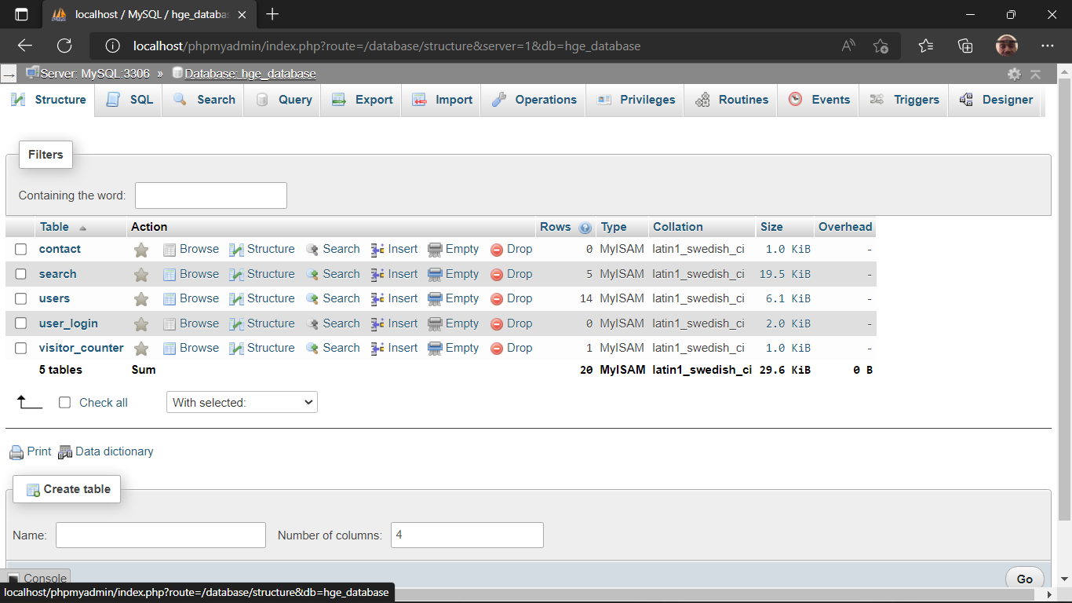

Using the ‘**setup.php’** to display all the created tables.

(fig25)

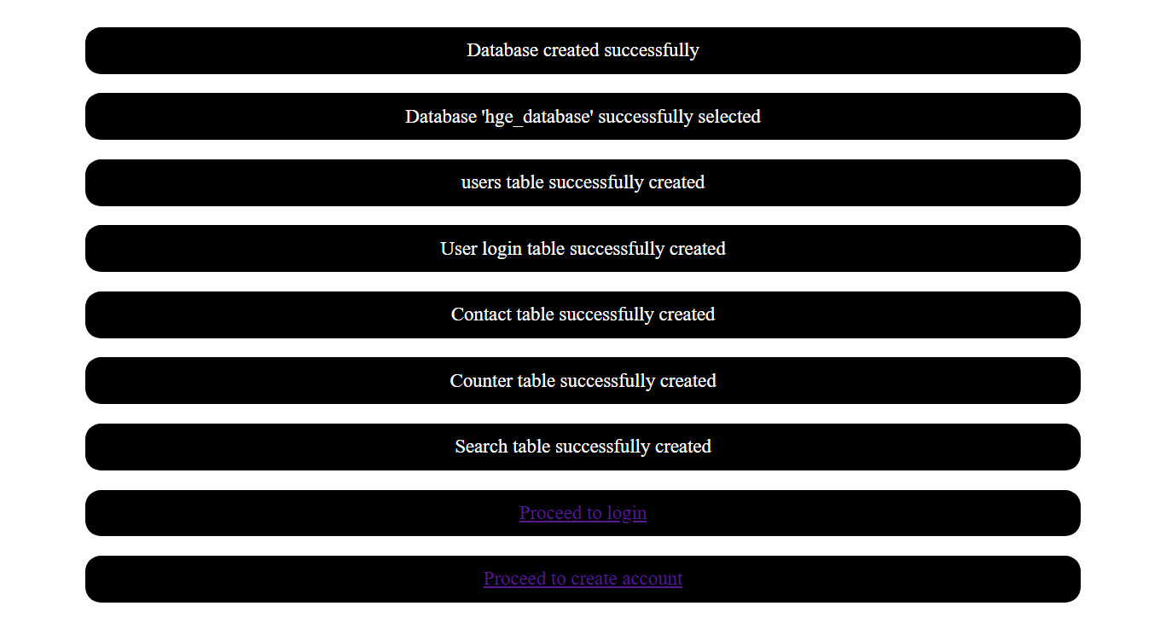

If the username is not found in the database or the login is unsuccessful, the user sees a prompt **(fig26)**

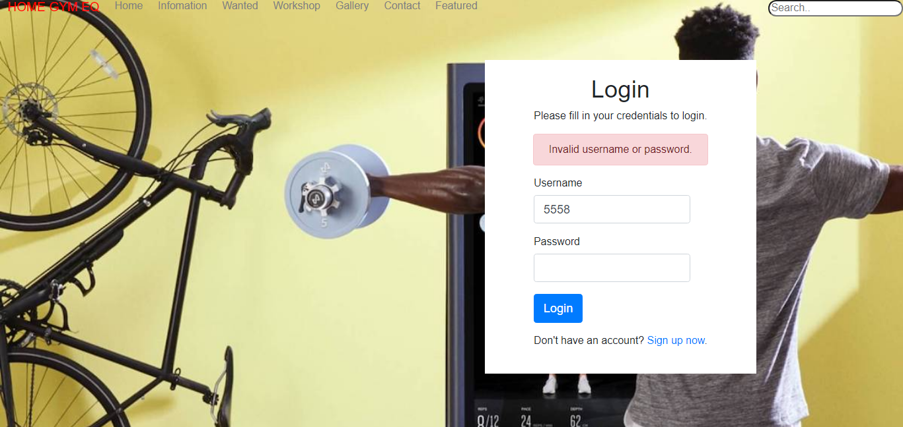

# **Task4**

**A Report Analysing the Home Gym Equipment Website**

**Introduction**

The website was built to enable the Home Gym Equipment company to expand its business ventures across its local community into the e-commerce space. As a result of this, it will help the company to communicate directly to its customers through sharing fitness information and news. Also visitors of the website can also contact Home gym Equipment and make enquires about products. Because of how complex the website is, it can be classified as **a web application.**

**What are Web application?**

Web application commonly known as a **Web App** is computer program that carry out certain tasks using the web browser. It has both a client side and a server side. Using a contact form as an example, the client side is where users enter data to fill the form and the server side stored all the data (Davu, 2013).

**Below are two web applications and their functions.**

These web applications have been implemented into the HGE website

* **Tawk.to (chatbot web application) –** This is a computer program that is able to mimic human conversations through text. This web application lives on the website and is able to interact with visitors. It uses a texting style interface. Chatbots are commonly used because, it required no additional coding making it easy to implement. Furthermore, it is an artificial intelligence chatbot which can assist visitors.

**Functions**

* **Can respond to multiple conversations simultaneously** – It is capable to interacting with multiple website visitors at the same time therefore and increasing efficiency
* **Saves Time –** it is capable of automating routine and scheduled tasks. As a result, visitors of the website will get immediate answers to their questions.
* **Increase engagement and sales -** it increases engagement through conversation. Chatbots create a communication channel where customers may connect without the burden of talking with a customer service personnel. Because it is powered by an Artificial intelligence, it can inquire about the user's purchase history and offer information that can influence their next purchase (Ubisend., 2017).
* **Saves Cost –** Chatbots web app, lives on the website and provides 24/7 customer service to anyone who visits the website. This saves the cost of having a robust customer service team for the website. As a result of this, Home Gym Equipment is able to attend to massive amounts of site visitors who need help (Brush, 2021).
* **Google recaptcha –** it uses advanced algorithms to protect a website from malicious bots, while giving genuine user the ability to login, create accounts and blocking un-genuine users (Google.com, 2022).

**Functions**

* Helps mitigate tariff on the website by separating the fake traffic from the real ones
* Helps prevent spam attacks on the website

* **Google map (web mapping application) –** It is a web program that uses the internet to browse, examine, or share a map-based visual representation of geographical data. This web applications makes it easy to create, edit and show a map without any additional code (Staff, 2018).

**Functions**

* **Helps customers easily locate the business -** It saves customers or site visitors the time and effort of leaving the website to look up directions to the business. Customers can easily access the website's map.
* **It increases its SEO and search ranking –** Having a mapping application on websites is considered by search engines to be advantageous. As a result of this, the website will be able to reach many people

**How these Web services Benefit Home Gym Equipment**

There are numerous advantages these web services bring Home Gym Equipment. The following highlights on them and how it adds functionality to the website;

* **24/7 support** - Because these systems are web based, Home gym equipment is able to access them 24/7. This makes it very flexible for the company to utilize them(gathering meaningful user data and enabling communication between many applications from various sources without the need to share sensitive data).
* **Simple Installation and Upkeep** – Web services are run by a third party, as a result of this, Home Gym equipment doesn’t have to go throught the struggle of adding additional code or upkeep. Updates and fixes are applied remotely and does not require any involvement of Home gym equipment to run, resulting in generally much lower maintenance requirements (senthil.k-wp, 2021).
* **More Security -** web based applications/services store all its data in the cloud. Because of this no information inputted into it is stored locally.
* **Time and Cost effective –** Having web services on the Home gym equipment websites means, the company does not need to reinvent new frameworks for the website. Since there are currently existing frameworks, the cost of developing new ones wastes time and money.
* **Increases Efficiency** – web services also help Home gym equipment website’s business operations to be streamlined. These web services implemented on the website are always active and can simultaneously attend to large amounts of customers / site visitors (EDUCBA, 2020).

**A description Of How HTML was used to develop the website**

HTML played a significant role in developing the Home Gym website.

Firstly, HTML was used to build the basic structure on the webpages. It was used to indicate headings, paragraphs, buttons and link elements. Furthermore, pictures and videos were placed into the web pages using HTML

**A description Of How CSS was used to standardise the developed website**

CSS played a significant role in styling the appearance of the home gym website. It was used to design the layout of the webpages and appearance, for example, the fonts, colours, alignments and other decorative features.

Furthermore, using an external CSS, all connected pages were affected by a modification to the style sheet, making the webpages look and feel more consistent

**Evaluation of the home gym equipment that makes use of web services and how well it satisfies the scenario's requirements.**

The home gym equipment websites use web services effectively that meet the scenario. These web services are well integrated into the website, example;

1. The home page contains a chat bot web service, that will enable visitors to community with the company and get feedback to questions
2. The google captcha verification web service, prevents spam and allows only real individual to login.
3. RSS feed shows news information about the company on the website

# **Task5**

A critical evaluation using the Rolfe D model

**What**(Description)

From the scenario, I was required a develop a website for, Home Gym Equipment company. The website required the following: 7 webpages, cookies information, slide show, captcha verification, number of view counter, RSS feed, interactive navigation bar and minimal text and images.

An external CSS was used to link all the pages. Furthermore, a database was created for visitor counter, visitor’s login, contacts form and a database search. Relevant information was input into the database search. **PHP** was used to connect the website to the database.

**So What**(Analysis)

The home gym equipment website is able to utilise web applications and services for its benefit. As a result of this, the company is able to reduce cost and save time while operating the website effectively.

My understanding of web services was deepened by this level of analysis.

**Now What**(Action plan)

The main goal of the home gym equipment website is to sell gym equipment and communicate with customers. The best action plan is to move to a cloud database. The large architecture of a cloud database will enable the storage of large amounts of records and also help the company reap all the benefits of having a cloud database.

# References

Brush, K., 2021. *SearchCustomerExperience.* [Online]   
Available at: https://www.techtarget.com/searchcustomerexperience/definition/chatbot#:~:text=A%20chatbot%20is%20a%20software,assistants%20to%20handle%20simple%20tasks.  
[Accessed 23 9 2022].

Davu, S., 2013. *Segue Technologies.* [Online]   
Available at: https://www.seguetech.com/web-services/  
[Accessed 23 9 2022].

EDUCBA, 2020. *EDUCBA.* [Online]   
Available at: https://www.educba.com/advantages-of-web-service/  
[Accessed 25 9 2022].

Google.com, 2022. *Google.com.* [Online]   
Available at: https://www.google.com/recaptcha/intro/invisible.html?ref=producthunt#:~:text=reCAPTCHA%20is%20a%20free%20service,users%20pass%20through%20with%20ease.  
[Accessed 1 10 2022].

senthil.k-wp, 2021. *Aezion.* [Online]   
Available at: https://www.aezion.com/blogs/the-benefits-of-web-based-systems-for-business/  
[Accessed 25 9 2022].

Staff, 2018. *The Last Call - RapidAPI Blog.* [Online]   
Available at: https://rapidapi.com/blog/top-map-apis/  
[Accessed 23 9 2022].

Ubisend., 2017. *Ubisend..* [Online]   
Available at: https://blog.ubisend.com/discover-chatbots/what-is-chatbot-for-website  
[Accessed 23 9 2022].